You will need to create a Marshmallow still life on one full page of your sketchbook.
Steps:
​At home, dump some Marshmallows onto a white piece of paper, and grab a desk lamp to exaggerate the lights and darks (if you are unable to do this, pop into the Art studio, create the Still life and take a photo with your phone)

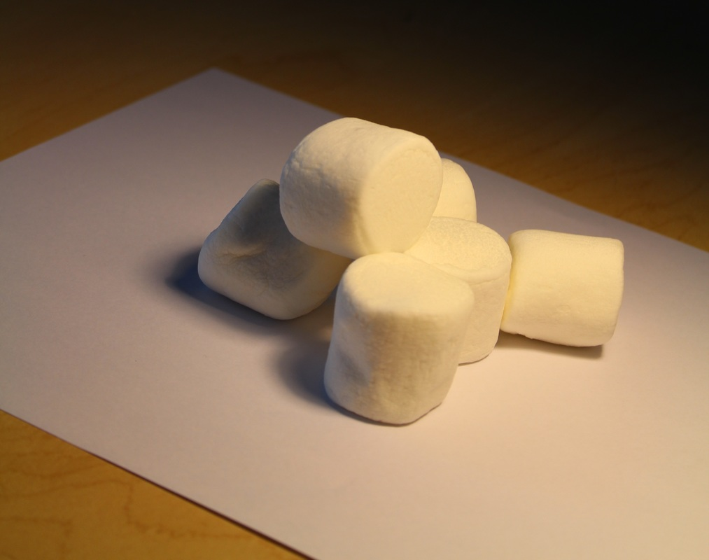
Time to begin....
1) Start by drawing the contours of each marshmallow (keep in mind, the drawing below is NOT of the same pile pictured above. Sorry!!)

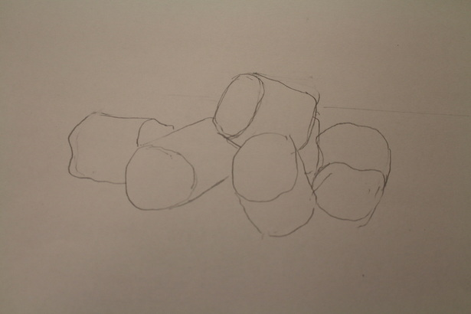

2) Using the side of your pencil, cover most of each marshmallow with a soft grey (approx. box 1 or 2 on your value scale that we did last week)
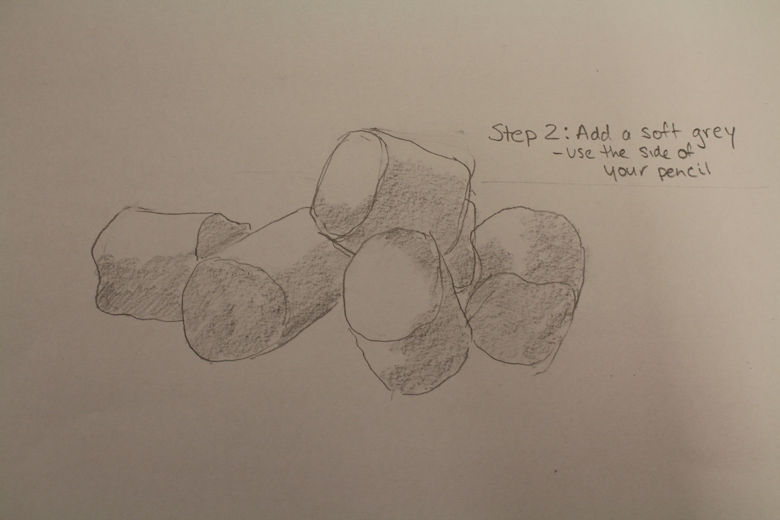
3) Now start to add a darker shadow in the darkest areas of each marshmallow. This darker shading should gently blend into the soft grey and then into white (like a value scale)
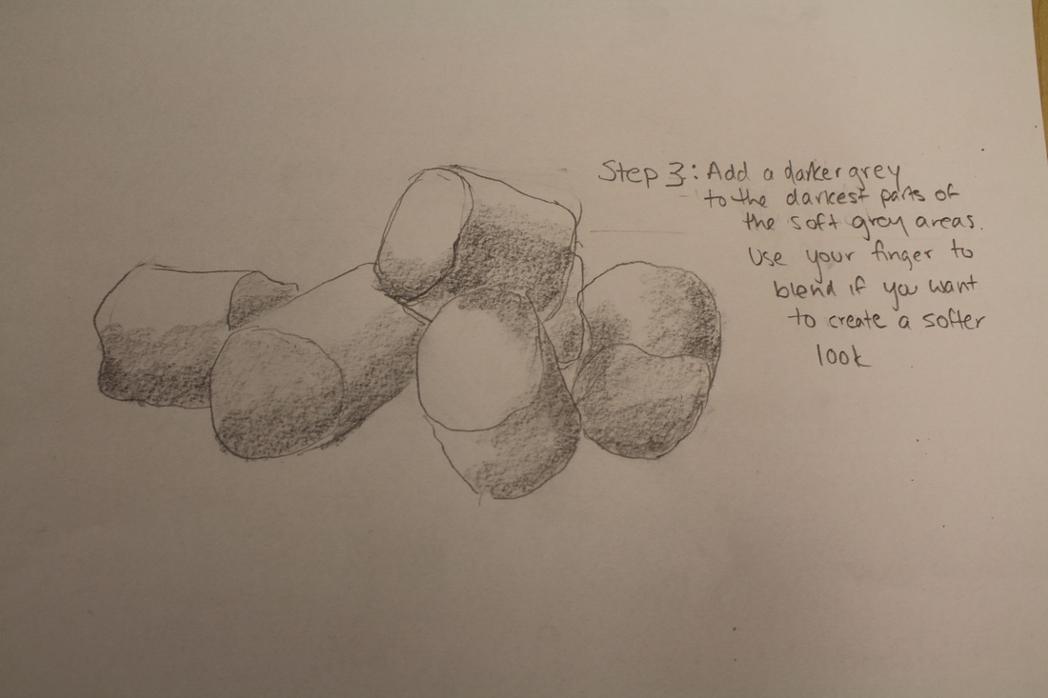
4) Next add the cast shadow (closely examine the shape of the shadow on each marshmallow). The Shadow should be darker at the base of each marshmallow
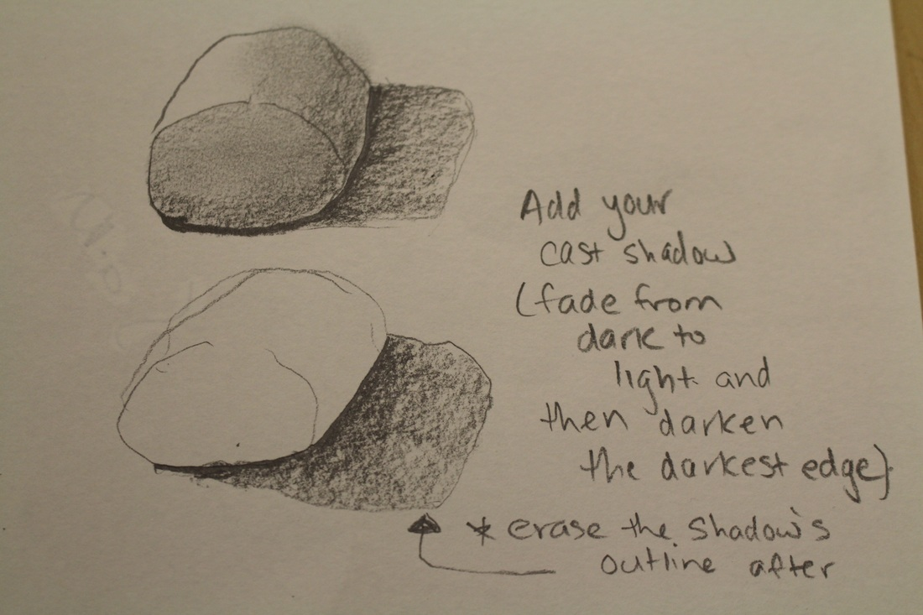

5) Now it's time to darken the 'inbetweens'. This makes the marshmallows pop off the page. Shade a dark value with the tip of your pencil wherever the marshmallow touches the ground, or in most cases another marshmallow. You can also darken the inbetween areas. Have a look at your composition. Can you see what I'm referring to?
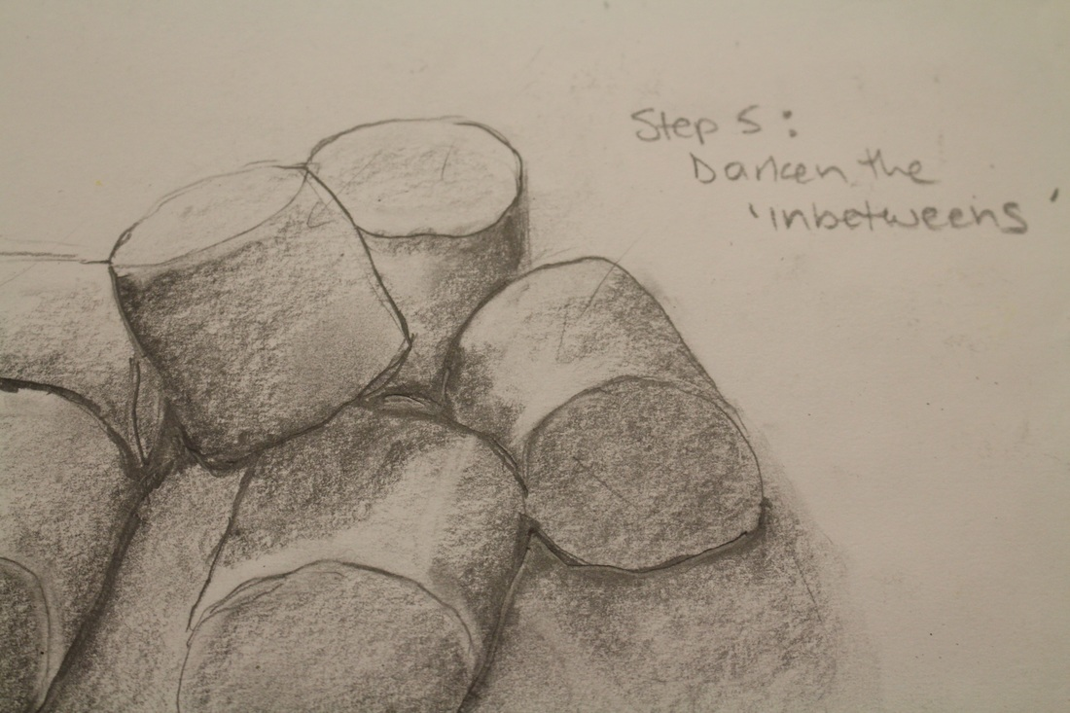

6) Lastly, it's time to tidy up your drawing. Make sure you've erased the outlines of the cast shadows (as shadows don't have outlines), you can also erase the obvious outline of each marshmallow, as marshmallows don't have outlines. You can smudge the marshmallows one by one, to make the colouring a little softer, but MAKE SURE that your last step is going in with the sharp part of an eraser to pull out any highlights that you may have lost when you began to smudge the image. Like adding darks, highlights also make the drawing 'pop'. Spray with fixative to prevent the graphite from moving.
All done! Are you proud of your drawing? How does it look? I didn’t get to this stage with my drawing, but feel free to go in and erase the outlines of each marshmallow. Objects in real life do not have outlines, they are made up of a combinations of different values.
