Ms. Spencer
Visual Art 11 Enriched
Course Syllabus
2016 – 2017
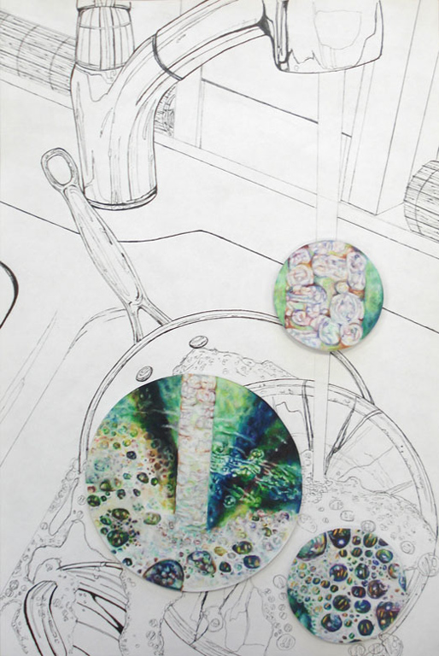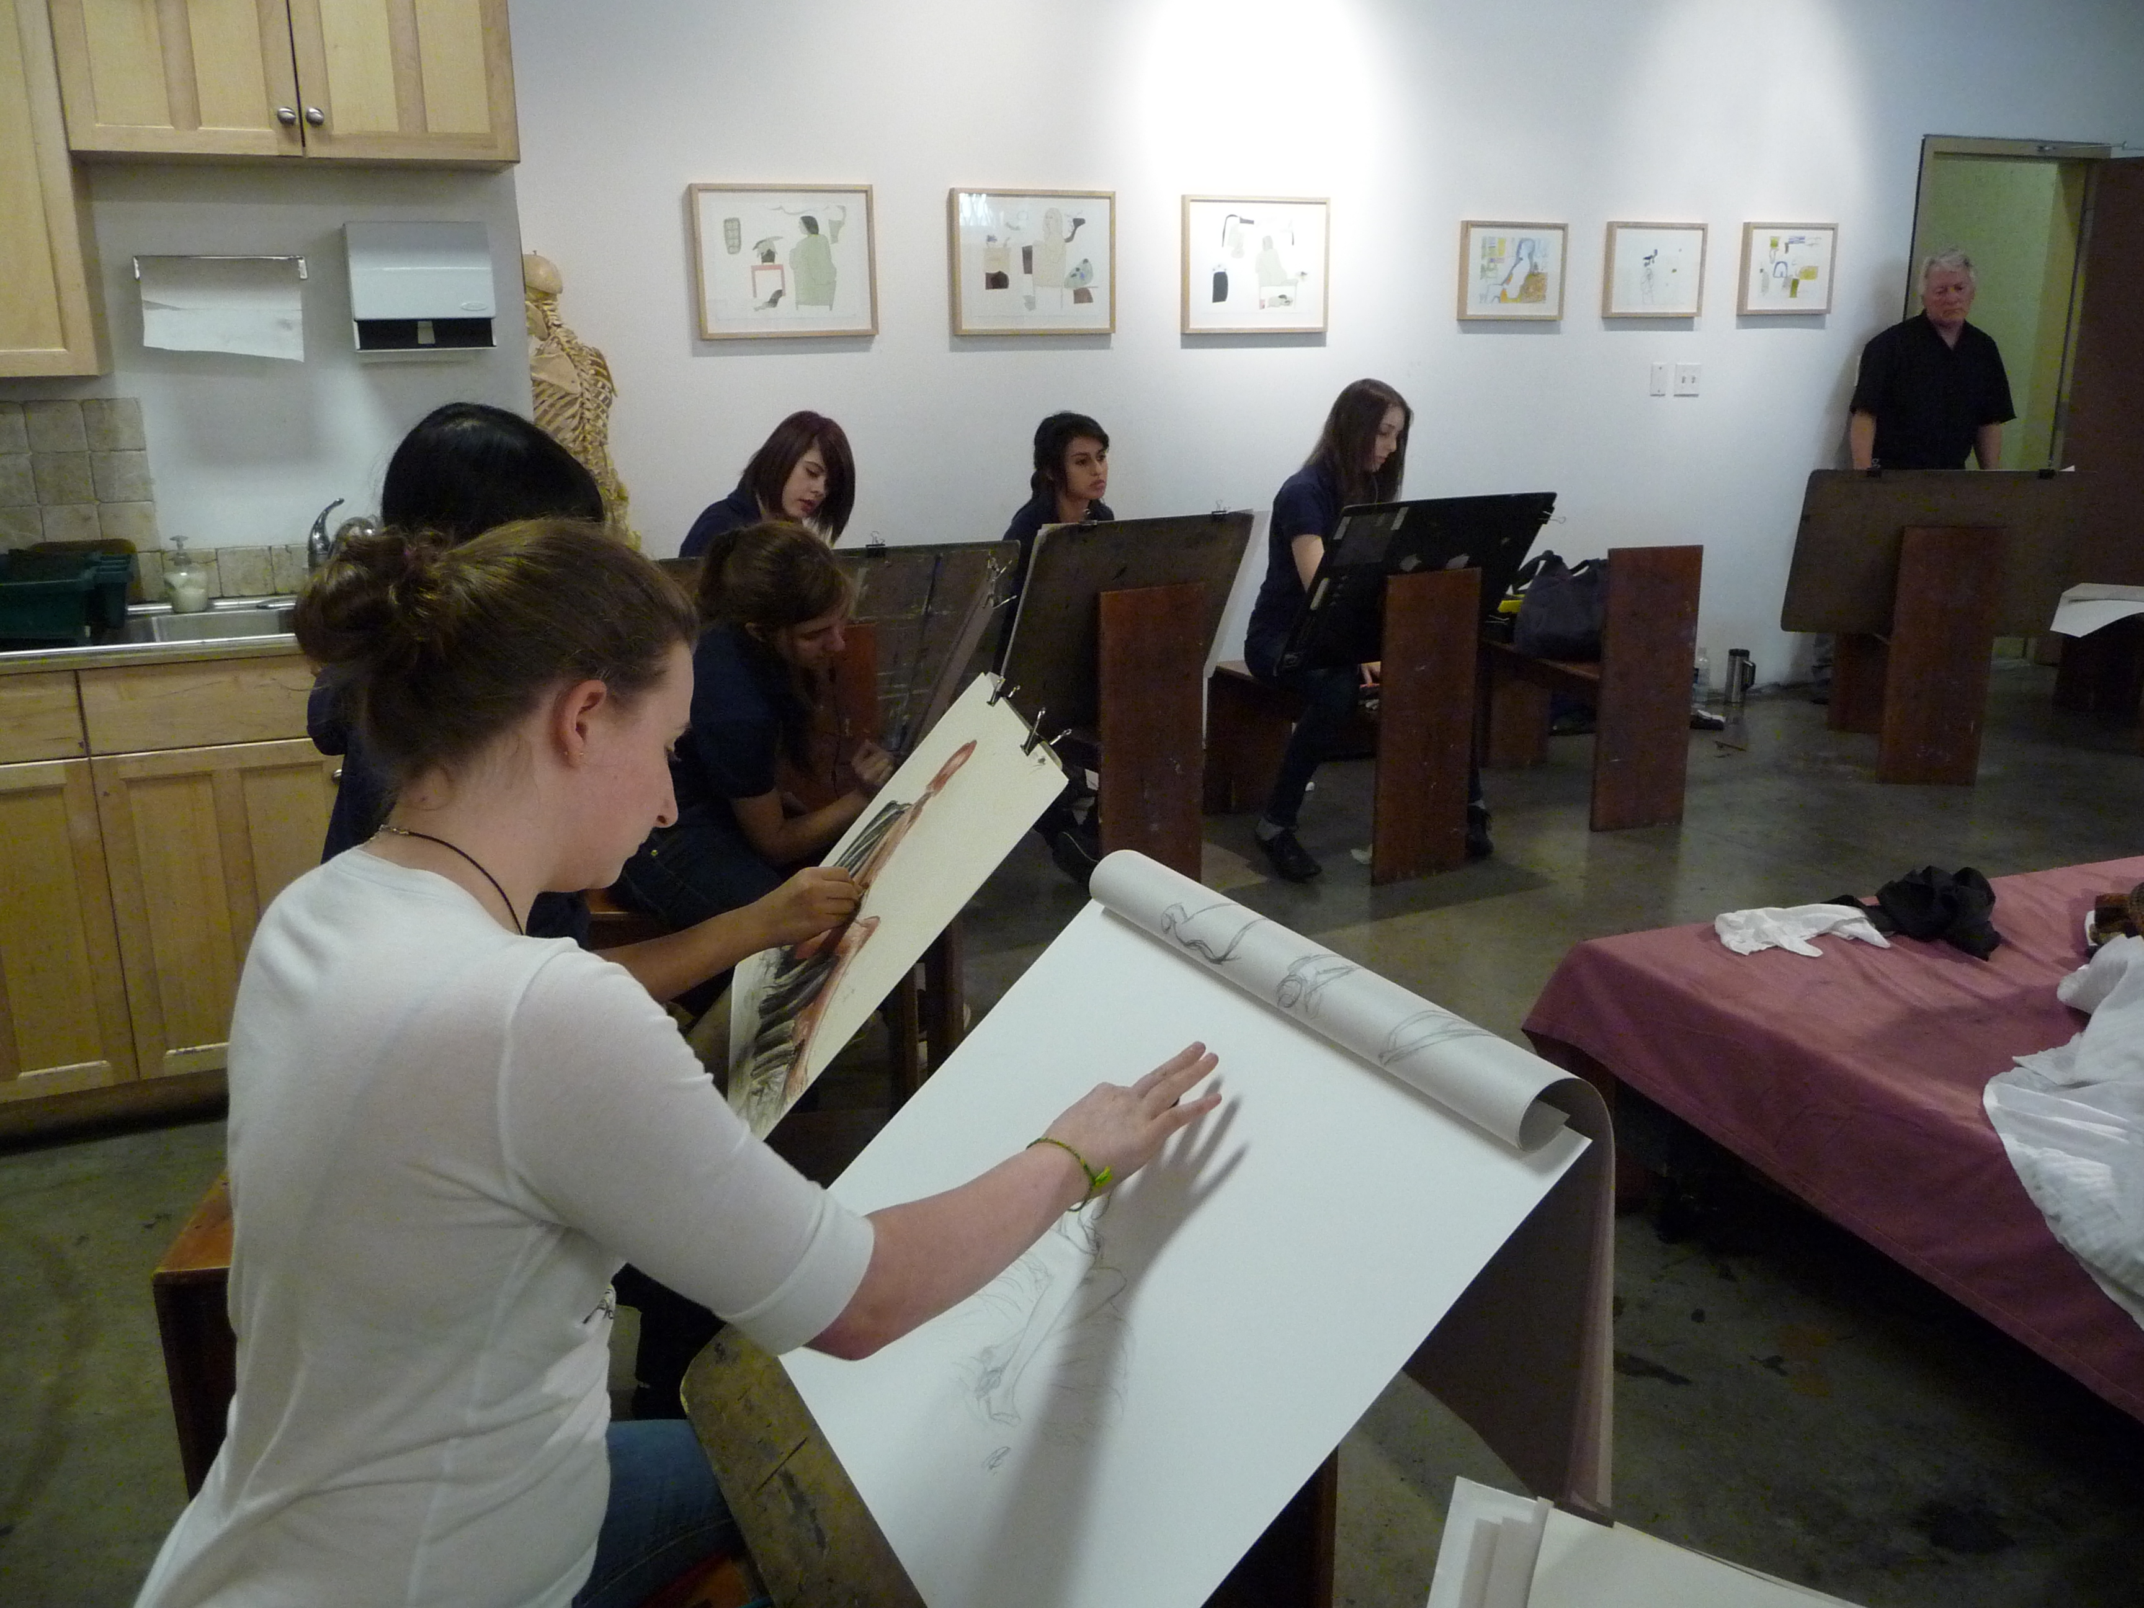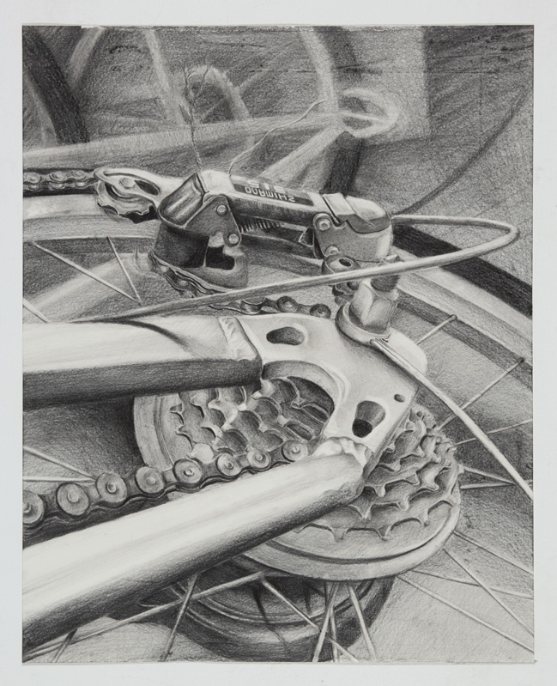
Course Description
The Visual Art 11 Enriched course is aimed at students who have an interest in the Advanced Placement Studio Art Program and its subsequent portfolios. The course is designed for students who are seriously interested in both the practical and theoretical experiences of art. It is essentially suited for students who are highly motivated, and who are willing to put forth a serious commitment to the program. AP® Studio Art is not based on a written exam; instead, students submit portfolios to the College Board for evaluation at the beginning of May during their grade 12 year. The Visual Art 11 Enriched Course is based on the premise that College/University level material can be taught successfully to secondary students, and the projects are designed to allow freedom in the structure of the course while keeping in mind that the quality and breadth of the work should reflect artwork at the post-secondary level.
The Visual Art 11 Enriched course has been designed to accommodate students who have expressed an interest in completing either the AP Drawing or AP 2-D Design portfolio. Students in Visual Art 11 Enriched are expected to go on to complete their AP portfolios in grade 12, however it is not mandatory that they do so. Therefore, all content of the Visual Art 11 Enriched course meets the requirements of the Breadth section of the AP Studio Art Program. Through direct teacher instruction, emphasis will be placed on the production of a volume of quality pieces of artwork. Students will address the breadth and quality sections of the AP portfolio in Visual Art 11 Enriched.
Important Contact Information:

My Email address: Courtenay.spencer@collingwood.org
My website: (the place to find project instructions often to be updated as units progress)
My Website:

http://theartsmock.weebly.com/

General Learning Outcomes
- To understand how to use the artistic process to create successful work based on “big ideas”
- To create meaningful and authentic work
- To let personal ideas and curiosity guide independent exploration and learning
- To demonstrate a breadth of high quality work (approx. 10 pieces)
- To discuss and begin to plan the development of the Concentration section of the final AP Studio Art portfolio
- To begin exploring postsecondary art/design options

Instructional Goals
- To encourage creative and systemic investigation of both formal and conceptual issues.
- To enable students to develop a mastery in concept, composition, and execution of either 2-D Design or Drawing.
- To emphasize making art as an ongoing “evolutionary” process that involves the student in informed and critical decision making.
- To Help students develop technical skills and familiarize them with the functions of the visual elements and principles.
- To encourage students to become independent thinkers who will contribute inventively and critically to their culture through the making of art.

Structure of the Advanced Placement Studio Art Portfolios:
- Quality – For this section, students are asked to submit 5 actual works in one or more media that exhibits mastery or essentially a student’s overall best work.
- Concentration – For this section, students will submit 12 slides (some may be details) where it is evident that an in-depth exploration of a particular artistic concern has been achieved. The works should be unified by an underlying idea that has visual and/or conceptual coherence.
- Breadth – For this section, students will submit a total of 12 slides of 12 different works where a solid understanding and application of visual principles and material techniques has been achieved. The best demonstrations of breadth clearly show experimentation and a range of conceptual approaches to the work.

Note: Visual Art 11 Enriched students will be focusing primarily on the breadth section of the portfolios
Copyright Issues
All work must be original. If students use someone else’s work or a published image as a basis for their own pieces, there must be significant alteration to the piece for it to be considered original!

Homework

As in any college-level course, it is expected that students will spend a considerable amount of time outside the classroom working on completion of assignments. Ideas for projects or solutions to problems should be worked out in a sketchbook both in class and outside of class. The sketchbook is an essential tool in recording ideas, capturing visual information, working on compositional issues, and just fooling around. Sketchbooks are checked frequently for progress.
Students are required to have a Pinterest account to be used for research and idea generation. Students will also be required to create and maintain a blog, which will be used for documenting the artistic process and reflecting on both their own work and that of both historical and contemporary artists.

Critiques

Students are required to participate in critiques at the end of each unit/project where there is an expectation to share and discuss individual work, develop and share opinions regarding the work of others, and provide and digest constructive criticism.

Open Studio

One day a week students are encouraged to meet after school for an open studio. A schedule of meeting dates will be posted. Some of these meeting will be open for students to work on projects independently and some will be structured drawing sessions. It is important that students arrive on time and be prepared to work during these meetings.

Exhibitions/Competitions

Visual Art 11 Enriched students are encouraged to participate in exhibitions and competitions. At the end of the school year, students will organize an exhibition of their work in the school galleries. Details about this exhibition will be provided toward the end of the year.

Assessment and Evaluation

Most assignments are open-ended in nature and explore a variety of approaches to drawing and 2-D design, and due dates are chosen to reflect the amount of time that generally is required to complete each assignment. After each assigned project due date, you will no longer be allowed to work on this project during class time. Due dates will be scheduled and students are expected to make every effort to complete the assignments by the due date. However, keep in mind that if you wish to be considered for major awards, (including colours), your work must be submitted by the end of the term in which it was assigned. I will also accept any work you wish to redo with the same deadlines applying. Marks may be taken off for late assignments as per the Collingwood School Punctuality Protocol, but will be decided on a “case by case” basis. It is important for students to stay on top of their work so as not to get behind. Flexibility of due dates is possible; however, a backlog of late assignments is certainly not encouraged given the amount of work to be covered in the course. If a student is having difficulty at any time in completing an assignment, she/he is encouraged to talk to Ms. Spencer ASAP to review the issues and make a plan! We all want you to be as successful as you want to be in this course!
Student work is evaluated on both a formative (in progress) and summative (finished product) basis. Assignment criteria for Breadth projects are clearly outlined; however, students are also encouraged to explore a variety of options when solving visual problems with teacher consultation. The teacher will regularly provide written feedback to students on their progress and the AP Studio Art rubric will most often be used so as to establish the standards students can expect to meet when the College Board evaluates their work.

Possible Assessment Tools
- Rubrics
- Blog posts tracking process
- Anecdotal Comments with Suggestions for Improvement

Evaluation of Student Achievement

Major Projects = 60%
Visual Journal /Bootcamps/Blog = 30%
Critiques/Participation = 10%

Collingwood’s Habits of a Successful Learner
It is expected students will work to improve their learning habits over the duration of the course. Please refer to the rubric, which outlines the various criteria and levels for meeting the criteria in the attached handout. Student progress of the Learning Habits will be evaluated by both the student and the teacher several times throughout the year.

Content of the Class:

The course includes the following three components:

- Study of contemporary/historical artists and trends. In addition to class work, students are expected to visit galleries and local art museums on their own. We will also be visiting “the flats” (main street area) galleries as a class and participating in a drawing from a live nude model at Basic Inquiry Studio. Date TBA.
- A “Visual Journal” or sketchbook to be composed of planning visual ideas, notes, photos, doodles, mini exercises and “boot camps”, short assignments, quick drawings, and practice of various techniques. Many art schools like to see students’ sketchbooks. Students will also be required to maintain a blog used for documenting and reflecting on the process and production of their artwork.
- Development of the breadth section of the student’s portfolio for AP Drawing or AP Design.

Course Overview & Timeline

The following topics will be covered in Visual Art 11 Enriched:

September/October (Weeks 1-8)
Explorations in Drawing:
- Observational Contour drawing
- Line quality
- Light and Shade/ Tonal drawing
- The rendering of form
- Gestural, Still Life, Life Drawing
- Compositional Techniques
- Elements and Principles of Design
- Expressive Mark Making
- Surface manipulation
- The illusion of depth (perspective)
- Exploration of various tools, materials and processes used to represent form and space: rendered, gestural, stylized, perspective, abstract
- Figure/ground relationships
- Proportion and scale
- Exploration of context: observation, viewpoint, psychological imagery
- Juxtaposition
Assignments:
“Iron Artist” challenge
Weekly Visual Journal Work
Blog Posts
“Bootcamps”: Contour, Gestural and/or Tonal Drawing Assignments, Line Drawing Assignments
Major Projects:
- The “Deconstruction” Drawing (RISD Challenge)
- Places and Spaces

November / December (Weeks 9-15)

Explorations in Drawing/ Mixed Media:
- Image making strategies: Observational drawing, use of personal photographs, use of grid system, light table, digital projector, opaque projector, image transfer techniques
- Pastel application techniques
- Surface manipulation
- Composition
- Rendering of form
- Elements and Principles of Design
- Colour Theory and Colour relationships
- Use of line, shape, and colour to create unity and variety
- Use of pattern to create rhythm

Assignments:
Weekly Visual Journal Work
Blog Posts
“Bootcamps”/mini assignments that focus on a variety of approaches to drawing
Major Projects:
- Consuming Colour
- Fractured Space

January/February (Weeks 16-22)

Explorations in Paint:

- Value and brush skills exercises
- Paint application techniques/surface manipulation
- Blending techniques
- Painting mediums
- Elements and Principles of Design
- Rendering of form
- The illusion of depth
- Colour Theory and the use of colour relationships
- Acrylic Painting Techniques
- Abstraction from nature/urban environment
- Painting from memory
- Creating a narrative
- Exploration of Expressionist mark making

Assignments:
Weekly Visual Journal work
Blog Posts
“Bootcamps”/Mini painting assignments dealing with a variety of approaches to painting
Major Projects:
- Remembered landscape
- Personal narrative painting

March/April (Weeks 23-28)

Explorations in Paint/Mixed Media Continued:
- Review of Lino Block Carving
- Mono Printing tools and processes
- Other printmaking techniques
- Elements and Principles of Design
- Use of positive and negative space
- Proper use of press and other printmaking materials

Assignments:
Weekly Visual Journal Work
Blog Posts
“Bootcamps”/Mini Assignments dealing with a variety of approaches to painting and mixed media
Major Projects:
- The Happy Project
- Connections

May/June (Weeks 29-34)

Explorations in Printmaking/Mixed Media:
- Review of Lino Block Carving
- Review of scratchboard
- Mono Printing tools and processes
- Proper use of press and other printmaking materials
- Positive/Negative
- Working with Symmetry/Asymmetry
- Elements and Principles of Design

Assignments:
Weekly Visual Journal Work
Blog Posts
“Bootcamps”/Mini Assignments dealing with various approaches to mixed media and printmaking

Major Projects:
- Analyze This: Mixed Media Project
- Final independent choice project

Notes:
- There will also be a life drawing field trip to Basic Inquiry which will require students to produce a number of Drawings. Date and specifications TBA.
- There will also be surprise “break days” scattered throughout the year where we will complete quick exercises that will be completed within 1 or 2 classes
Resources
The following is a list of resources that is regularly used to fuel both theory and content behind projects, critiques, and lectures/discussions during the course:
Drawing with Imagination, Bert Dodson, North Light Books, 2007

Drawing Basics, Jacklym St. Aubyn, Wadsworth Thomson learning, 1998

Drawing Lab, Carla Sonheim, Quarry Books, 2010

Design Principles and Problems, Paul Zelanski, Mary Pat Fisher, Thomson Wadsworth, 1996

Drawing for Older Children and Teens, Mona Brooks, Penguin Putman Inc. 1991

Hooked on Drawing, Sandy Brooke, Prentice Hall, 1996

Drawing a Contemporary Approach, Claudia Betti & Teel Sale, Harcourt Brace College Publishers. 1997

Drawing on the Right Side of the Brain, Betty Edwards1999, Penguin Putnam Inc.
Figure Drawing: The Structure, Anatomy, and Expressive Design of the Human Form, Nathan Goldstein, 2004, Pearson Prentice Hall
Freehand: Sketching Tips and Tricks Drawn from Art, Helen Birch, Chronicle Books, 2013
Paint Lab, Deborah Forman, Quarry Books, 2014
Art Fundamentals: Theory and Practice, Ocvirk, Stinson, Wigg, Bone, Cayton, 2002, McGraw Hill
The Usborne Complete Book of Art Ideas, Fiona Watt, 2010, Usborne Publishing Ltd.
365 Things to do with Paper and Cardboard, Fiona Watt, 2011, Usborne Publishing Ltd.
Journal Fodder 365, Eric Scott and Davis Modler, 2012, North Light Books

